# Package Installation Guide

## Step by step guide to install and update packages

This section will detail the system requirements and UiPath packages to be available in the system to ensure that it executes the codes correctly. Follow the steps to install the package in UiPath studio:

**Step 1.** Click on Manage Packages.

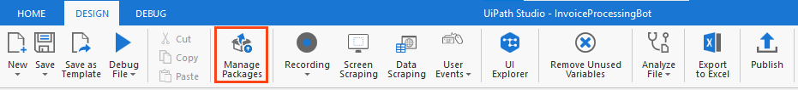

Figure 1 Manage Packages Ribbon Bar

**Step 2.** Search the package according to the project requirement.

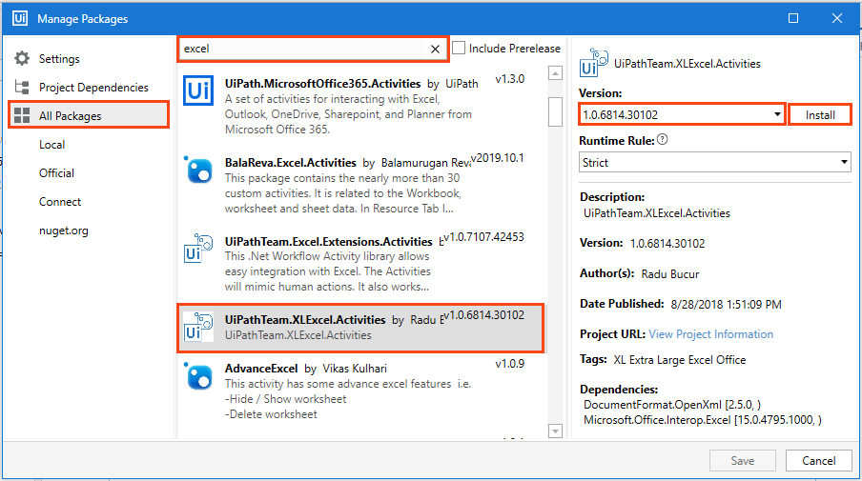

Figure 2 Package Installation

**Step 3:** Select the package and the version to be installed.

**Step 4:** Save the packages by clicking on the “Save” button.

## Viewing list of installed Packages

To view the packages used in code, right-click on the “Dependencies” option of “Project” panel and select “Manage” option (refer Figure 3).

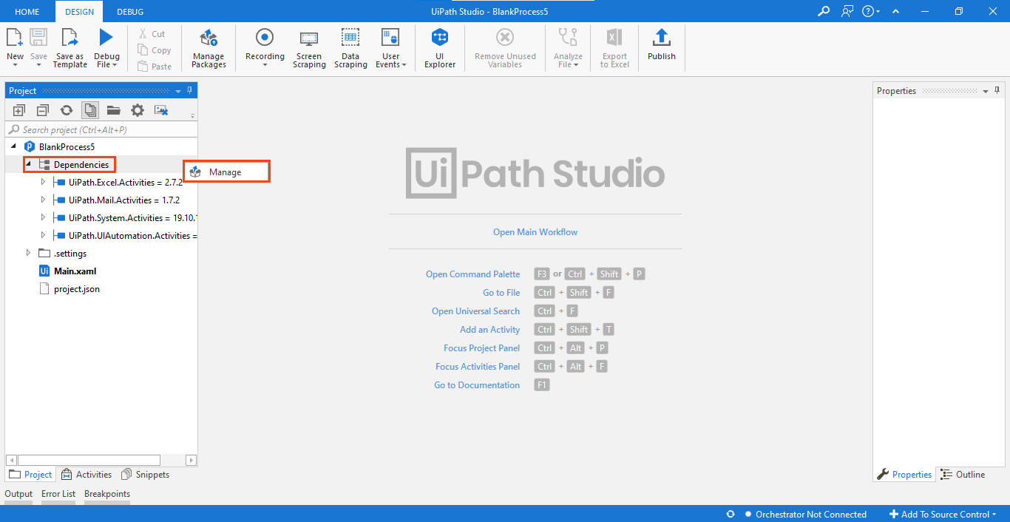

Figure 3 Installed Packages List

Note: For the codes which involve browser usage, the browser should have its extension installed. You can install an extension from the 'Tools' section of UiPath Studio.

# Basic Projects

## Disk Monitoring & Clean-Up Robot

The code comprises of two packages (refer Table 4) and they must be installed in the studio for the Robot to execute the task successfully.

* UiPath.System.Activities
* UiPath.UiAutomation.Activities

Table 4 List of Packages used in 'Disk Monitoring& Clean-Up Robot'

The above-listed packages used can be viewed on the left side of the "Project" panel tab (refer Figure 10).

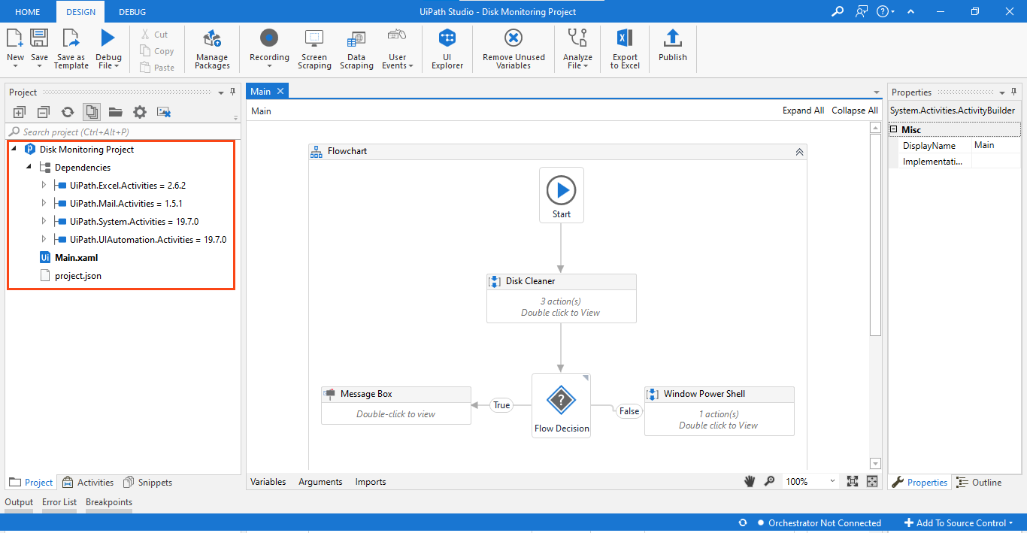

Figure 10 List of Packages used in 'Disk Monitoring & Clean-Up Robot'

Right-click on "Dependencies" and select "Manage" to view all project dependencies (refer figure 11).

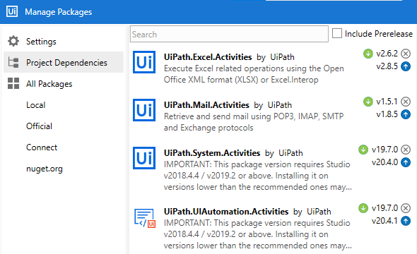

Figure 11 Project Dependencies in ‘Disk Monitoring’

**Note: If a package appears in 'Red' it indicates a problem. To resolve it, right-click on the package name and click resolve/update.**

**Prerequisite:**

* ‘C’ drive should be available in your system.
* Create two blank folders in 'C' drive as follows:
  + ‘new folder’
  + ‘removefolder1’

## Process Flow

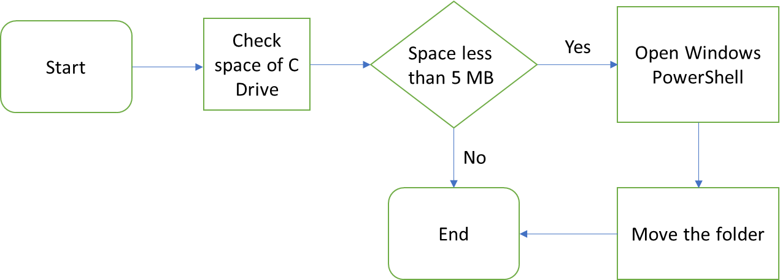

## Applications to be used

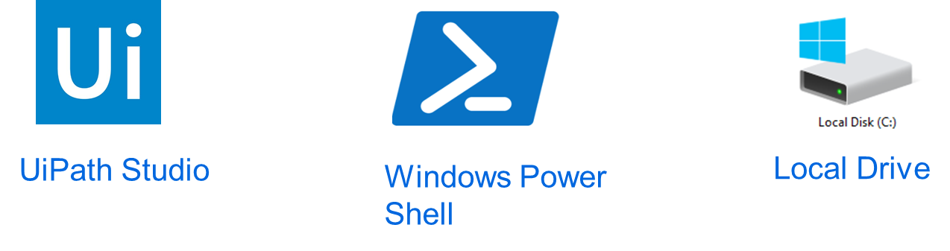

Based on the scope, applications to be used for Disk Monitoring and Clean-Up Robot are:

1. **UiPath Studio:** Used to create the Robot.
2. **Windows Power Shell:** Used to remove folder from the drive to another folder.
3. **Local Drive:** C Drive is used. Disk monitoring and cleaning conducted on this drive.

## Process steps



**Project Overview:** This project aims to build a Robot for monitoring the disk usage of system and then act according to predefined rules. The robot will check if the system has utilized more than the specified space. If the remaining space is less than 5mb, then the robot will move the specified folder, else it will inform the user that the drive has enough space.

## Steps to make a Disk Monitoring and Clean-Up Robot:

**Step 1:** The Robot will check the available disk space of C drive.

**Step 2:** Checks the condition if available disk space is less then or greater then 5mb.

**Step 3:** If available space is greater then 5 MB, it will send pop up on screen with “Drive has enough space”.

**Step 4:** If available space is less then or equal to 5 MB, it will open Windows PowerShell application and type command to move ‘new folder’ under ‘removefolder1’.

**Step 5:** Once the folder is successfully moved, then process will end.